Tableau: Power Start Workbook

# WORKSHOP MODULES

1. Connect to Data and Data Transformation
2. Overview of Tableau Basics and Concepts
3. Create a map showing data
4. Create a bar chart showing data
5. Create a line chart showing data
6. Create an interactive dashboard combining charts

# HOW THE WORKSHOP “WORKS”

At the beginning of each module, the instructor will demonstrate the drills to be done. Then, the student will be asked to do the drills on their own. Feel free to work at your own pace. The instructor will be circulating while you do the drills. If you run into a problem, please raise your hand. At the end of each module is a STRETCH TIME / BONUS WORK section. If you are ahead of the class, feel free take a non-disruptive stretch and do the bonus work. Please wait for the instructor before going to the next module.

# ABOUT THE DATA

The data set used for these examples is a subset of a data set from the World Bank (<http://data.worldbank.org/data-catalog/crowd-sourced-price-collection)>. The data was collected as part of a pilot study examining the feasibility of crowd-sourced food price data collection. Price data was collected by non-professionals for thirty specific food items across several months in eight countries. The dataset file contains geographic data (city and country), time data (week of observation), product information (name, quantity) and price (in US dollars).

[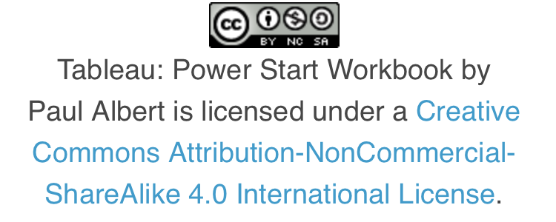](https://creativecommons.org/licenses/by-nc-sa/4.0/)

|  |
| --- |
| Module 0: Connect to data and data transformations **DRILL 1: Connect to and clean data**   1. Open Tableau Desktop. 2. Click on the  icon on the top left, review the options offered on this screen. 3. On the Connect Pane, click Excel. 4. Navigate to the **Foodstuff Dataset** file on your PC and open it. 5. View the data in the preview pane below. 6. Find the data field called Location. Split this field into City and Country.    1. Click the dropdown menu triangle for the Location column ()and select **Split**.    2. Tell Tableau that Location 1 is a City by clicking on  icon and choosing **Geographic** **Role** => **City**.    3. Tell Tableau that Location 2 is a Country by clicking on  icon and choosing **Geographic** **Role** => **Country/Region**.    4. Rename “Location – Split 1” to **City**    5. Rename “Location – Split 2” to **Country.** 7. *We can see from this screen that what we have now is a row for each location giving prices observed across multiple observation weeks. This might be a good format to visually display the data, but it is a poor way to allow the data to be analyzed. We need to make the data “tidy.” To make our data tidy, we want to do what Tableau calls “pivoting.”*    1. Use the Shift key to highlight all the Week columns (January 1, 2012 through April 29, 2012).    2. Right click the selected columns and choose **Pivot**.    3. Rename the column “**Pivot Field Names**” to “**Date**” and the column “**Pivot Field Values**” to “**Nominal Price**.”    4. Tell Tableau to treat the **Date** field as a date by clicking on  icon and choosing **Date**.   *To review, we’ve cleaned up our data for analysis by 1) taking a location name that was formatted “city, country” and breaking it out to two properly tagged fields and 2) making our data tidy by pivoting it so that each row only contained a single observation. Well done!*    Figure 1. Data Interpreter view after data cleaning   1. Now, click onto “Sheet 1” at the bottom to get started!   STRETCH TIME / BONUS WORK:   1. This workshop tags the topic “CONNECT TO AND CLEAN DATA” as Module 0, not Module 1. Why? 2. Go to **Tableau Online Help** by selecting **Open Help** from the **Help** option on the **Toolbar**. Search for the term “Excel” using the top right search field. Review the various help pages. Search for “data interpreter” and review the various help pages. 3. Mute your computer and click on the  icon on the top left and then, on the right Discover pane, click on the “Connecting to Data” topic. Remember this option for when you can play videos with audio. 4. Do a Google search on “Tidy Data” and review the Wickham PDF that will be towards the top.  Module 1: Overview of Tableau basics and concepts  1. We want to aim to go beyond merely describing data to analyzing data in order to gain insight. A good way to approach data analysis is to start by asking questions of the data. If we do this right, the questions we ask will often change based on the previous answers we get from the data. Data analysis is an iterative journey, not a final destination.      1. Fields are broken up into Dimensions and Measures.    * **Dimensions** (blue) are categorical fields. They are the labels in a visualization, the buckets that data falls into such as locations, product names, etc.    * **Measures** (green) are quantitative fields. They are the axes in a visualization, the numbers that can be analyzed, such as price and counts of records. 2. Tableau creates some fields that can be used in a visualization that do not exist in the original data set.    * If the data set contains geographic fields, such as country or city, Tableau searches an internal database and generates **Latitude** and **Longitude** fields. This enables the geographic data to be plotted on a map.    * **Number of Records** is a simple count of rows in the data set. 3. **Show Me** can be accessed in the upper right corner of the screen. With field(s) selected, Show Me offers one-click options for chart types. 4. The Tableau Canvas:    * Data window – purple – drag fields from here to bring them into the view, either data fields or, if you’re on the Analytics tab, items like reference lines and box plots.    * Shelves – blue – areas where fields can be placed to control exactly how they appear in the view.    * Canvas – green – where the visualization is built. Fields can be placed directly here as well as on shelves.    * Toolbar and ribbon – orange – additional controls and menu options, including Undo and Clear Sheet.     Figure 2. Tableau Canvas  Take the next few minutes and explore Tableau and the data. Drag some fields from **Dimensions** and **Measures** on the left to the **Rows** and **Columns Shelves** to see what happens. Hover over the various Ribbon icons to display what they do. Ask a question and try to answer it, play with dragging fields to different places or using Show Me to get a feel for how the software behaves.  Practice using the “Undo” and “Redo” buttons on the Toolbar ().  STRETCH TIME / BONUS WORK:   1. Do Foodstuffs and Product Codes have a 1:1 relationship? 2. What is the relationship between Food Type and Foodstuffs? 3. Does each Foodstuff have a common way of being measured (**Quantity**)? 4. How many different Quantity types are there? 5. Which Weeks/Countries/Foodstuffs have the most observations? |

# Module 2: Create a Map showing Data

Drill 2: Map the Average Prices Observed

1. Clear the sheet  (in the ribbon) or create a new sheet 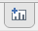 (at the bottom)
2. Double click **Country** from the data window.
   1. If you get anything other than a map, undo and try dropping the field **Country** into the large, bottom right rectangle that says “*Drop field here.*”
      1. Alternatively, double click on the field name to bring **Country** out as a map.
   2. Note that the generated Latitude and Longitude were automatically plotted on the Rows and Columns shelves.

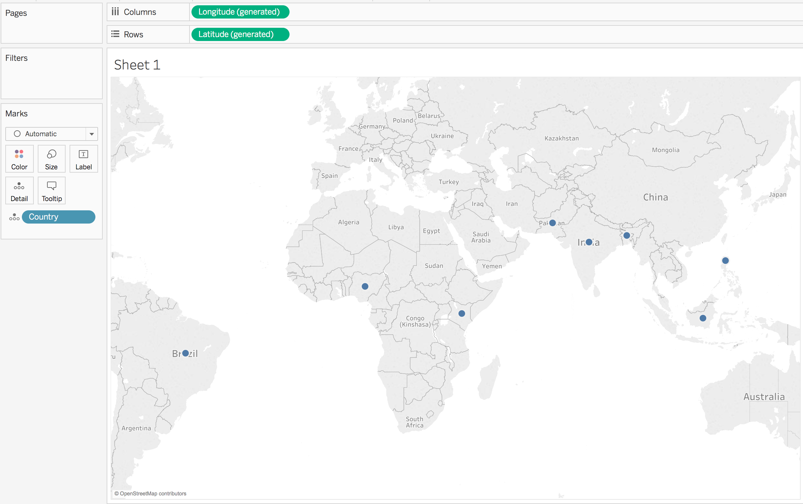

Figure 3. Initial map view

*Which country has the highest average nominal price?*

1. Drag **Nominal** **Price** from Measures on the right to the **Color Shelf** (button that says Color).
   1. This should create a filled map colored on a gradient of “SUM(Price).”
   2. Note that the default aggregation is SUM, *let’s change that to average*.
2. Right click (on a Mac, control + click or two-finger click) on the Price pill on the Marks Card that says “SUM(Nominal Price).”
3. Select on the option **Measure** and then **Average** to change the aggregation calculated from Sum to Average.

*Hover over the various countries on the map, find the one with the highest average price.*

1. Double click on the tab for the bottom of the sheet and name it “Countries.” What happens to the chart title (hint, it went from Sheet 1 to Countries)? Double click on the chart title and explore options for changing/formatting the chart title.

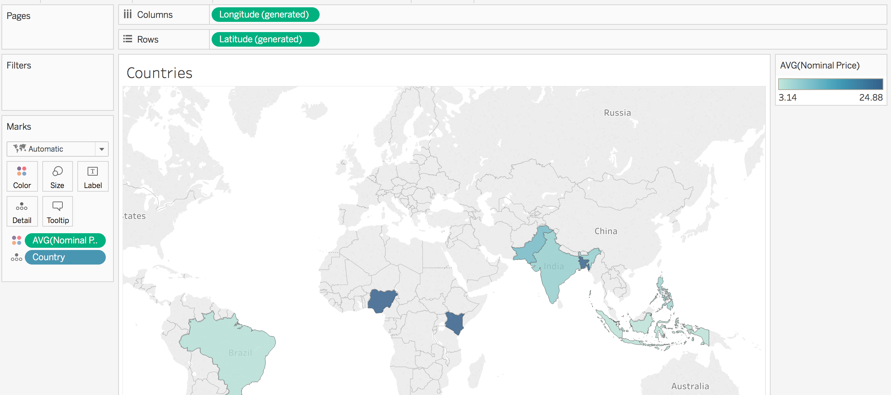

Figure 4. Colored map (choropleth) view

STRETCH TIME / BONUS WORK:

1. Each Country is being colored by Average Nominal Price. What is the numerator and denominator that Tableau is using to make this calculation?
2. Go to **Tableau Online Help** by selecting **Open Help** from the **Help** option on the Toolbar. Click on **Design Views and Analyze Data** on the left. Click **Build and Use Maps**. Explore the different pages under **Mapping in Tableau**.
3. Notice the “Tooltip” information that appears when you hover over a Country. Click on the Tooltip Card (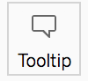) and explore formatting and reordering the way tooltip information appears.
4. Go to the Maps Layers options from the top Toolbar, explore the various options offered.
5. Go to the Maps Options option from the top Toolbar, explore the various options offered.
6. Create a new sheet and see if you can create a bar chart showing the number of price observations by country and city (see next page for directions on creating a bar chart). Name this sheet “Bonus Bar.”

# Module 3: Create a bar chart showing data

DRILL 3: Compare Foodstuff Nominal Prices

First, let’s compare the average nominal price for each Foodstuff in the dataset.

1. Create a new Worksheet by clicking on the new sheet icon on the bottom right () . Rename the sheet to **Avg and Std Prices.**
2. Drag the **Nominal** **Price** measure pill to the **Columns Shelf** and the **Foodstuff** dimension pill to the *Rows Shelf*. What we get is a bar for each Foodstuff showing the total prices recorded for each Foodstuff.
3. Right click on **Sum(Price)** **Pill** on the **Columns Shelf** and change the *Measure* type to *Average*.

This shows the Average Nominal Price per Foodstuff. Let’s make this easier to understand by sorting the bars. Click on the **Descending Sort** button on the Toolbar (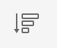) to sort the bars.

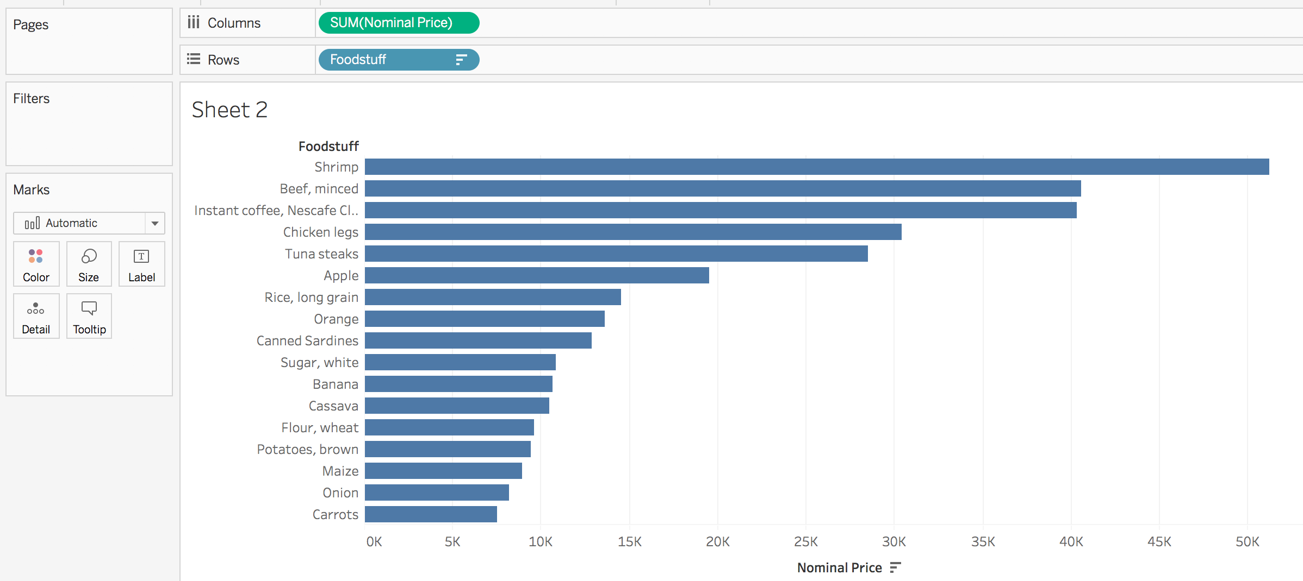

Figure 5. Bar chart of Nominal Prices

DRILL 4: Explore the different quantities USED to report Nominal Prices

*According to the data, Shrimp has the highest Average Nominal Price. However, let’s take a closer look at the data to see if this measure poses an analytical challenge.*

1. Drag the **Quantity** pillfrom **Dimensions** to the front of the **Foodstuff** pill on the **Rows Shelf.**

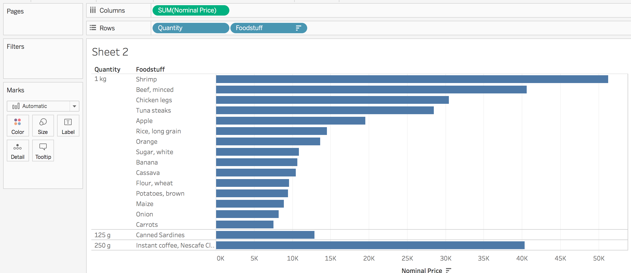

Figure 6. Bar chart of Nominal Prices organized by Quantity Type

*As Figure 6 shows, the nominal price for Shrimp is being given for quantities of “1 kg” and for Canned Sardines for quantities of “125 g.” If we want to compare the prices of the various Foodstuffs more accurately, we need to standardize quantities. To do that, we need to create a calculation.*

DRILL 5: Create a Standardized Price Calculation and Compare Nominal and Standardized Prices Across Foodstuffs

Detailed Steps:

1. Create a new Worksheet. Rename it to **Avg and Std Prices**
2. Drag **Price** to the **Columns Shelf**, change the aggregation to Average by right clicking on the pill.
3. Drag **Product Name** to the Row shelf.
4. *Overview of the Calculation Editor – for a more thorough discussion of Calculations, refer to the Online Help.* 
   1. *Calculation name – orange – give your calculation a name.*
   2. *Calculation editor canvas – green – areas where calculations can be built. These calculations may include, but are not limited to, using fields, functions, and other operators.*
   3. *Functions – blue – using functions, you may compute values such as a sum, average, and minimum, to name just a few. You can use the menu to drill down into specific types of functions (date, string, number, etc.).*
   4. *Function description – purple – additional information using the function.*

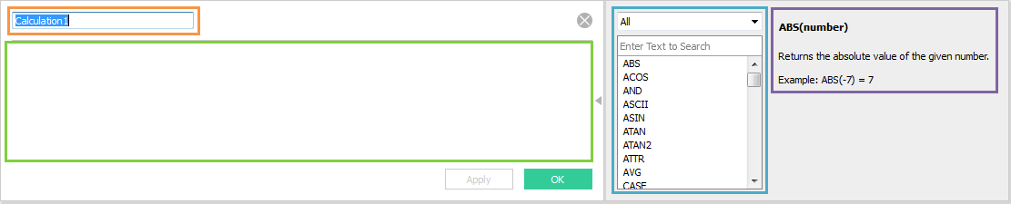

Figure 7. Calculation Editor overview

1. Now, let’s open the calculation editor and create our calculation. Right click on **Quantity** in the **Measures** pane on the right side, **Create**->**Calculated Field**.
2. Name your calculation “**Standardized Price.**”
3. Create the calculation as shown below and select OK.

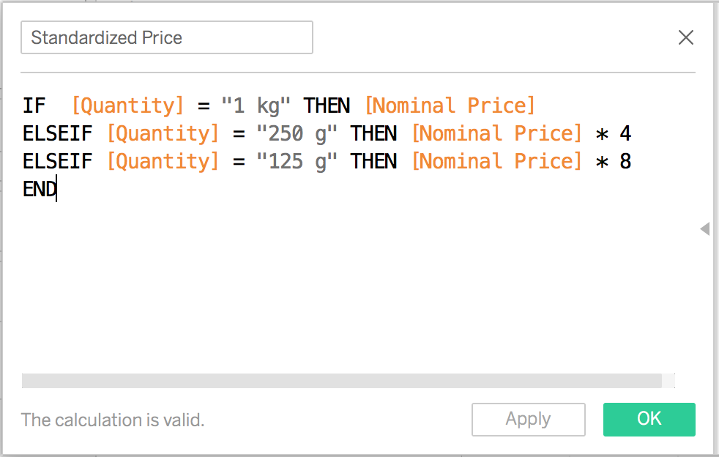

Figure 8. Calculation Editor showing Standardized Price calculation

1. *Let’s polish up the calculation by changing the default aggregation Tableau will use for it.* Right-click on field **Standardized Price** under **Measures** and set **Default Properties** > **Aggregation** > **Average**.
2. Drag **Standardized Price** Pill to the **Columns Shelf**, to the right of **AVG(Nominal Price)**.
3. Now you can sort on both **AVG(Standardized Price)** and **AVG(Nominal Price)** by clicking .
4. Click on 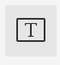 in the **Tool Bar** to display the values for each bar.

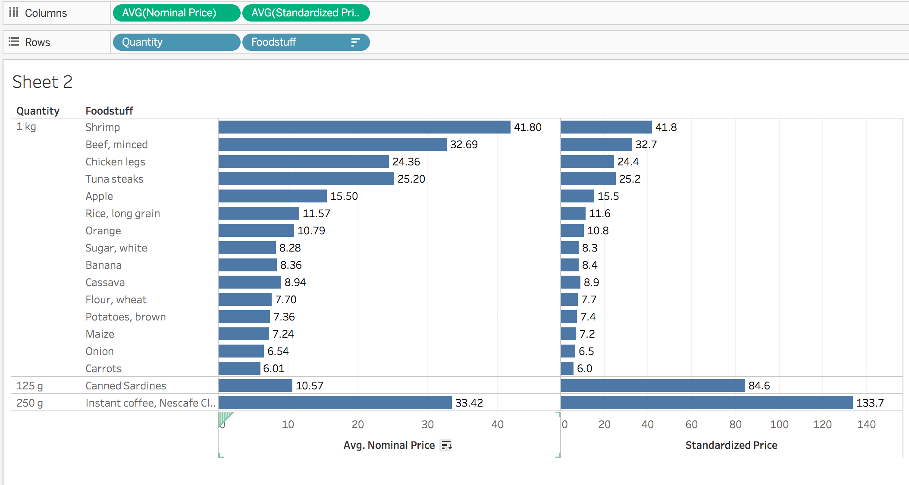

Figure 9. Dual bar chart showing Nominal and Standardized prices

Hover over the axis labels Nominal Price and Standard Price until you get a sort icon. Use this icon to sort the views.

*While Shrimp has the highest Nominal Price, Instant coffee has a standardized price more than 3X higher!*

*If the analysis relates to variation across categories such as Country or Foodstuff, what visualization type makes the most sense to use?*

*If the analysis relates to variations across time, what visualization type makes the most sense to use?*

DRILL 6: Compare prices across Foodstuffs and Countries

1. Create a new sheet ( at the bottom) and name it “Price Variation by Country.”
2. Holding down the Control key (Command on a Mac) click to select the fields: **Country**, **Foodstuff**, **Standardized Price**.
3. With those three fields selected, click on the **Show Me** tab on the upper right.
4. *Show Me will display what types of visualizations can be shown for the selected data.* Click on available options displayed to see how the data can be displayed for the selected chart type.
5. Select the Horizontal Bar Chart option to choose that type and click the **Show Me** tab again to close it.
6. Experiment by moving the pills around between the **Rows Shelf** and **Columns Shelf**.
7. For our analysis, let’s end with **Country** and **AVG(Standardized Price)** pills on the **Columns Shelf** and the **Foodstuff** pill on the **Rows Shelf**.
8. *Let’s make the chart easier to decode by sorting the bars.* Right click on the **Foodstuff** pill on the **Rows Shelf**. Choose **Sort** and specify sort order to be descending. Note the handy icon that appears now on the pill to tell you the category is being sorted.
9. *Position of elements is one of the primary ways we decode what to pay attention to in decoding information. We just changed the position of the Foodstuffs to make the chart easier to decode. Would it be easier to read the chart if we rearranged countries (maybe by continent or by those with relatively higher or lower prices)?* Try rearranging the order of the countries by clicking and moving columns.
10. *Let’s make the chart easier to decode by coloring the bars for each country differently.* Drag a **Country** from **Dimensions** on the right to the **Color Shelf**.

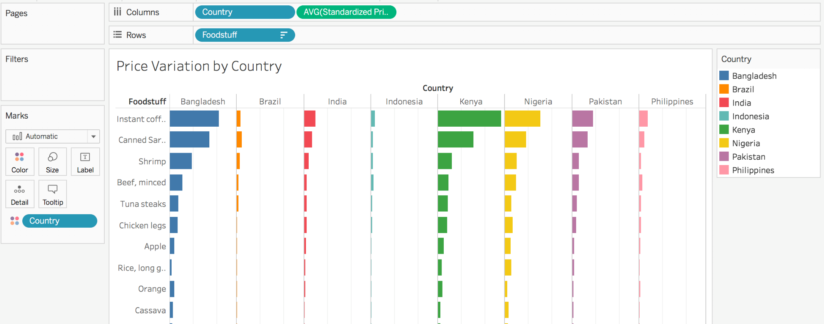

Figure 10. Bar chart showing Standardized Prices by Foodstuff and Country

Drill 7: Create a reference line for each Foodstuff bar showing overall price per Country

*Let’s take this analysis a little further. What we want to do is add a bar to each line showing the average price per product for all countries to aid in our analysis.*

1. Right click on the X axis area and choose **Add Reference Line**, set **Scope** to “**Per Pane**,” set **Label** to “**Value**” and then click “OK.”

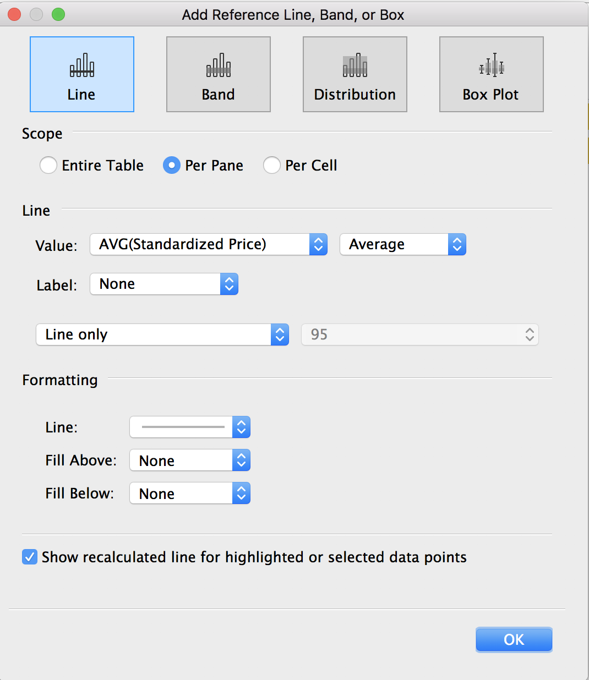

Figure . Reference Line Editor

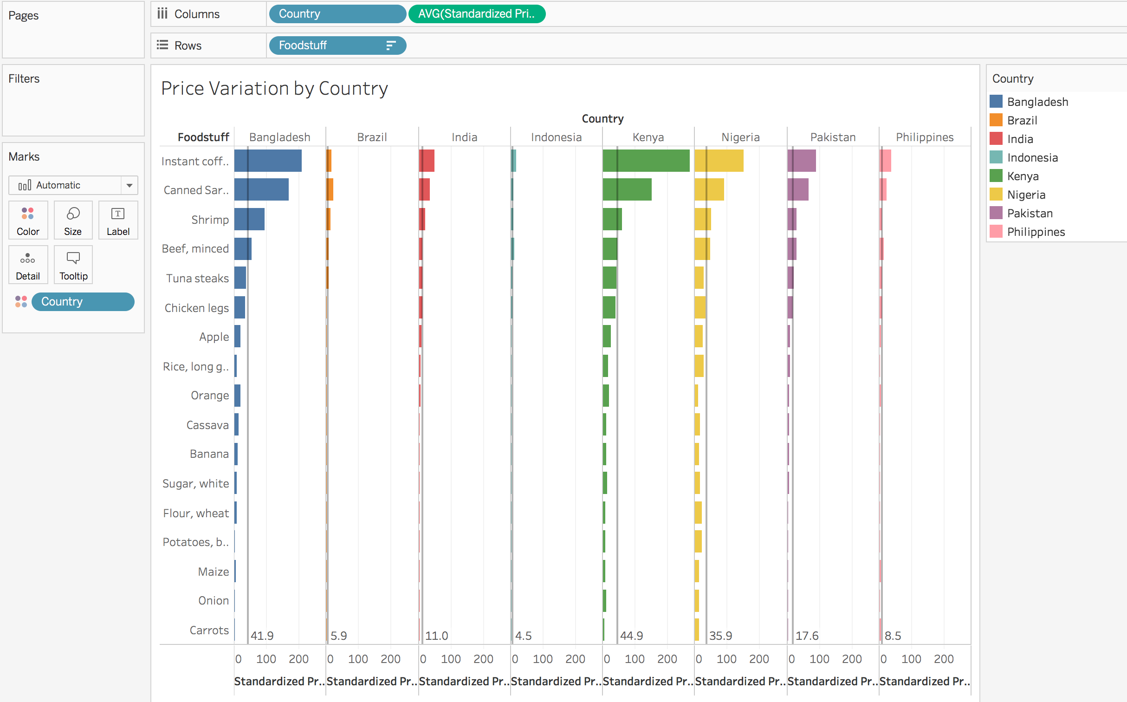

Figure 12. Bar chart with reference lines

*Stop for a second and think about what these average price reference lines actually show. Tableau is calculating the reference line to be the [sum of average standardized prices paid for Foodstuff] divided by [count of Foodstuff categories]. While, when properly understood, this can be a useful calculation to consider, it could also be easily misunderstood. Certainly, we do not have the data to show comparable prices for a standard market basket or average regional diet to allow us to compare overall prices across countries. What we can do, however, is determine the overall average price per Foodstuff and use that to help compare countries. Make sense?*

Drill 8: Create a calculation to show the average price paid per Foodstuff across all Countries and use this CALCULATION FOR a new reference line

1. *Well done! You are now about to learn a more advanced topic in Tableau called a Level of Detail Expression!* Right click on **Standardized Price** in the **Measures Pane** on the left and choose to **Create a calculated field**.
2. Create the Expression to calculate the Average Price per Product for all countries.
   1. Name your calculation “**Avg Std Price per Foodstuff.”**
   2. Create the calculation below:

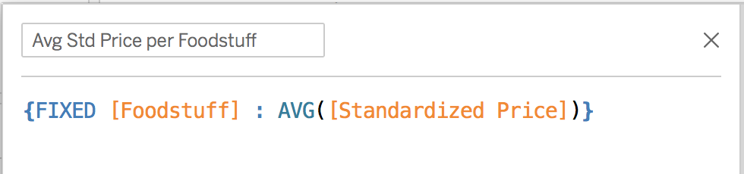

Figure 13. Calculation for overall average standardized price per Foodstuff

* 1. Select OK

1. *To use this calculation to draw a new reference line, we need to bring it into the view so it can be used.* Drag the **Average Std Price per Foodstuff** calculation to white space at the bottom of the Marks Card.

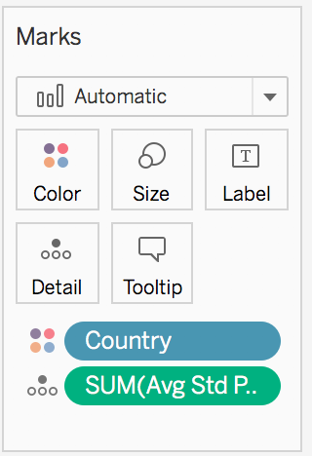

Figure 14. Marks card with Average Std Price pill

1. *Now we have the calculation we just created available to let us change the reference line to use this instead.* Right click on the bottom axis area and select **Edit Reference Line**, select the “Scope” to be “Per Cell,” and use the pull down window for “Value” to select the value to display to be “Avg Std Price Per Foodstuff”. For “Label,” choose “None.” Click **OK**.

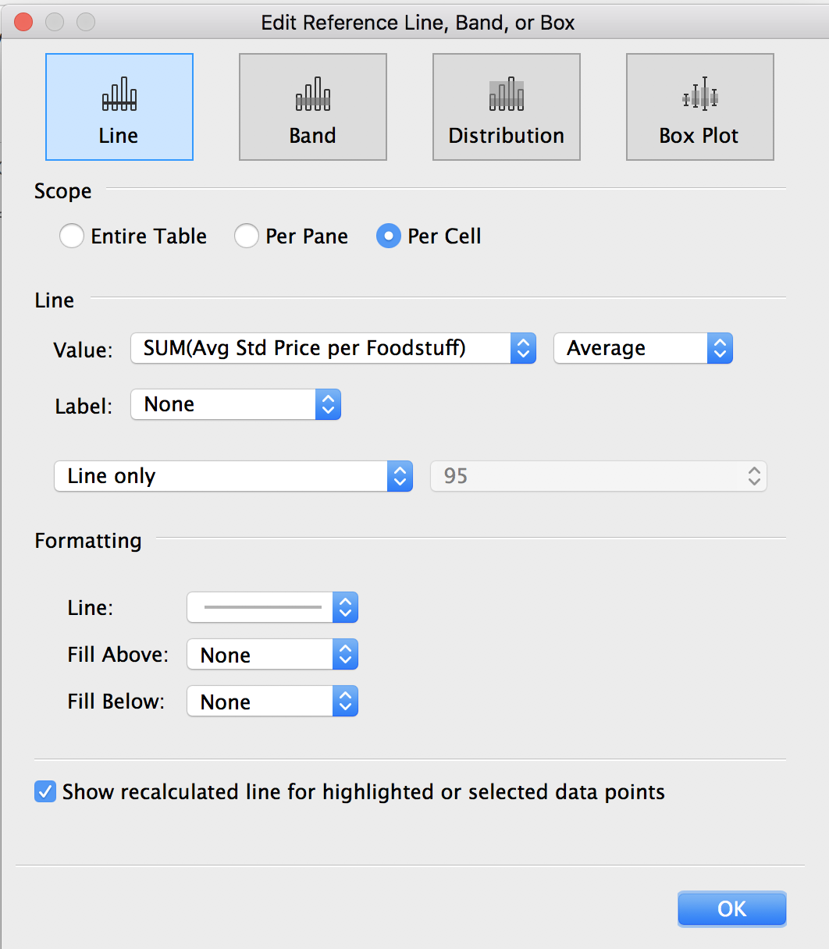

Figure 15. Reference Line Editor adjusted to show Average Price

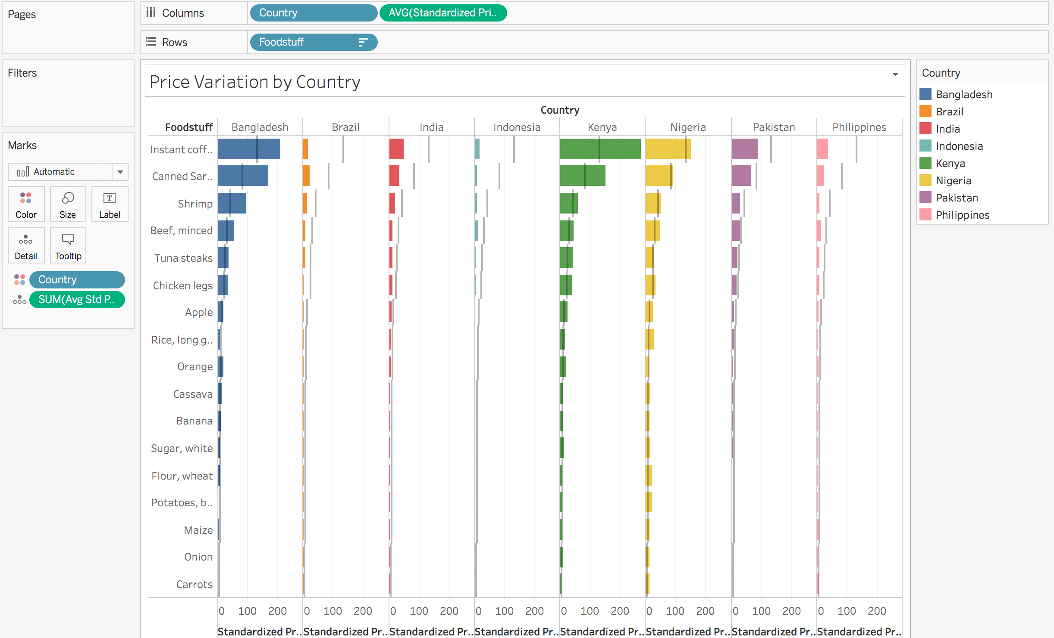

Figure 16. Final bar chart with new reference lines

*Is it easier now to compare prices across countries? Which country would you want to go to in order to purchase Instant Coffee? Canned sardines?*

STRETCH TIME / BONUS WORK:

1. In the last drill (Figure 16), the aggregation type for the calculated field **Avg Std Price per Foodstuff** was left as “SUM.” Can you figure out why that does not matter in our analysis? Why Tableau is actually using displaying the average for this measure?
2. Go to **Tableau Online Help** by selecting **Open Help** from the **Help** option on the **Toolbar**. Click on **Design Views and Analyze Data** on the left. Click on **Advanced Analytics.** Explore the different pages under **Calculated Fields** and then the pages under **Analytics**.
3. Mute your computer and click on the  icon on the top left and then, on the **Discover Pane** on the right, click on the “**More training videos**” topic. Click on the pulldown for the **Calculations** topic to display available videos. Remember this option for when you can play videos with audio.

# Module 4: Create a line chart showing data

Drill 9: Examine Foodstuff Price Dollar Variations by Time

*Now that we have a feel for how price observations compared across Foodstuffs for countries, let’s see how price observations changed over time.*

1. Create a new sheet ( at the bottom) and name it “Price Variation ($) by Time.”
2. Drag **Date** from **Dimensions** on the right to the **Columns Shelf**.
3. Drag **Standardized Price** from Measures on the right to the **Rows Shelf**.
4. *Tableau defaults to aggregating the* ***Week*** *data to a single year; we are shown just one point (because all of our observations happened during 2012). Let’s display this data by week instead*. Right click on the **Date** pill on the Columns Shelf and choose to aggregate by **Week Number**.
5. *Now, let’s make our analysis a bit richer by creating a line for each type of Foodstuff.* Drag **Foodstuff** to the **Color Shelf** (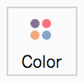).

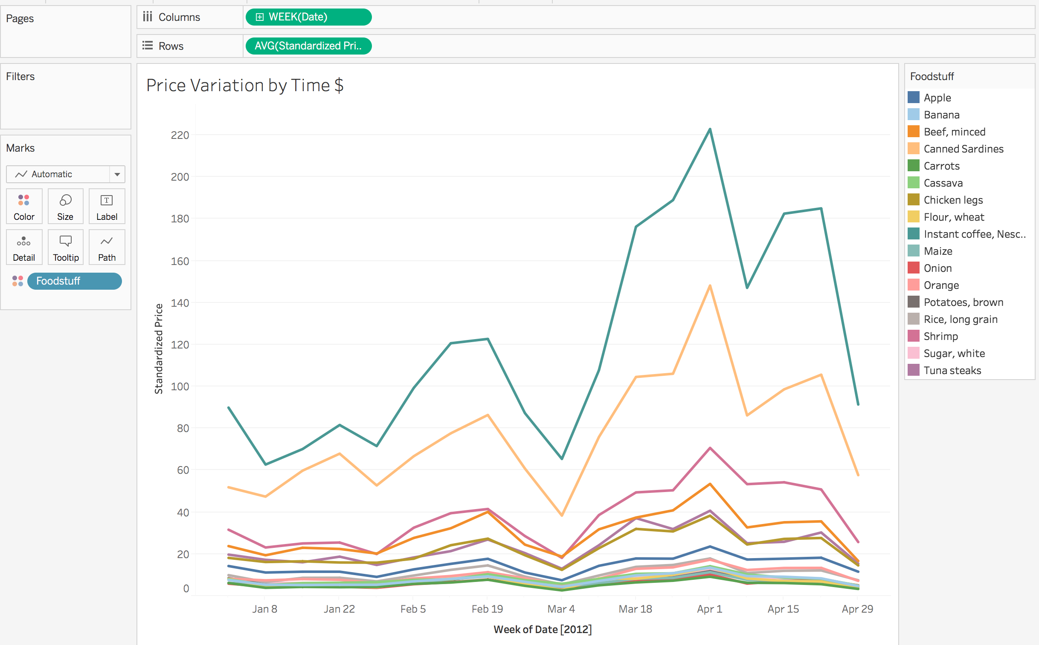

Figure 17. Line chart showing Price Variation ($) for each Foodstuff

*What just happened? By dragging* ***Foodstuff*** *to the* ***Color Shelf,*** *we asked Tableau to show a line for each type of* ***Foodstuff****. Try dragging the Foodstuff pill on the Marks Card to the Detail Shelf. In this case, we just asked Tableau to break out a new line for each* ***Foodstuff*** *without giving each line a unique color. Drag the* ***Foodstuff*** *pill back onto the* ***Color Shelf*** *or hit undo to go back to the Figure 17 view.*

*Figure 17 shows the movement of prices across time in absolute dollar terms. While easy to understand, the relative movement of lower cost Foodstuffs is being “drowned out” by higher cost Foodstuffs. To make our chart easier to decode, let’s try examining the movement of prices in a more relative way, by percent of change from the previous price. To accomplish this, we are going to use a feature of Tableau called “Table Calculations.”*

Drill 10: Examine Foodstuff Price Dollar Variations by Time

1. Right click on the last chart’s (Figure 17) bottom tab and choose “Duplicate as Crosstab.” Name this sheet “Price Variation (%) by Time.”

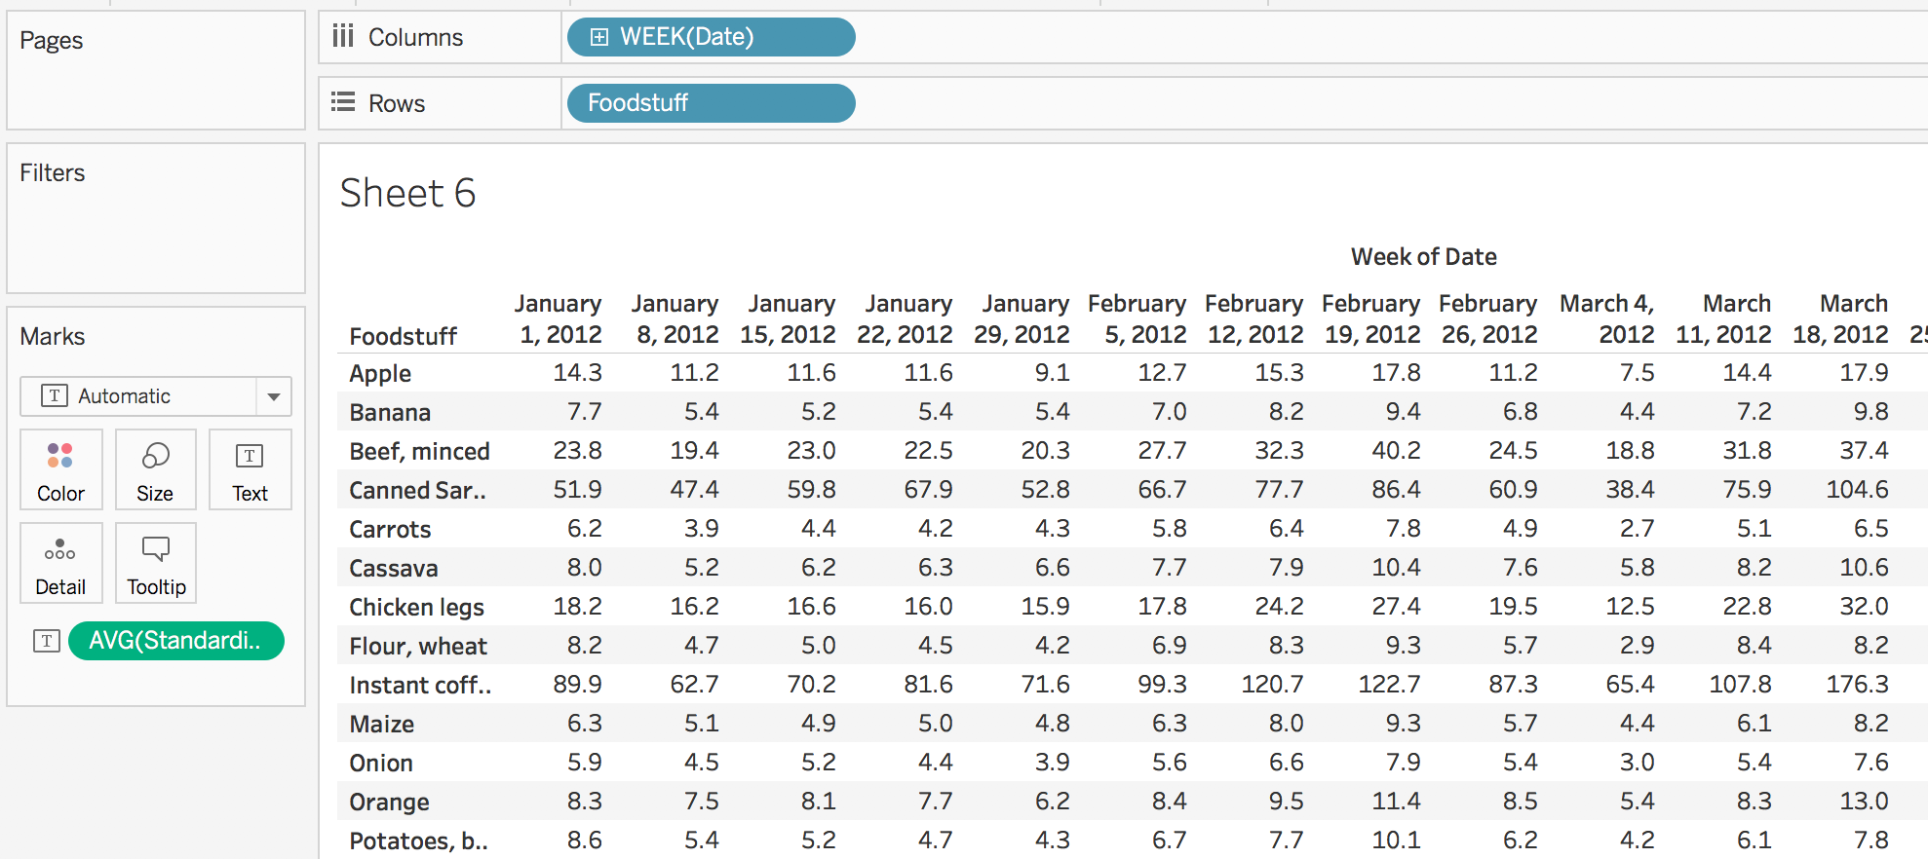

Figure 18. Crosstab to demonstrate Table Calculations

1. Right click on **Avg(Standardized Price)** pill on the row shelf (see arrow on Figure 18). Choose **Add Table Calculation**. Begin by playing with the various options to see how various settings can change the values calculated. For our final settings, set the **Calculation Type** to*Percent Difference From,* **Compute Using**to*Table (across)* and **Relative to** to*Previous****.***

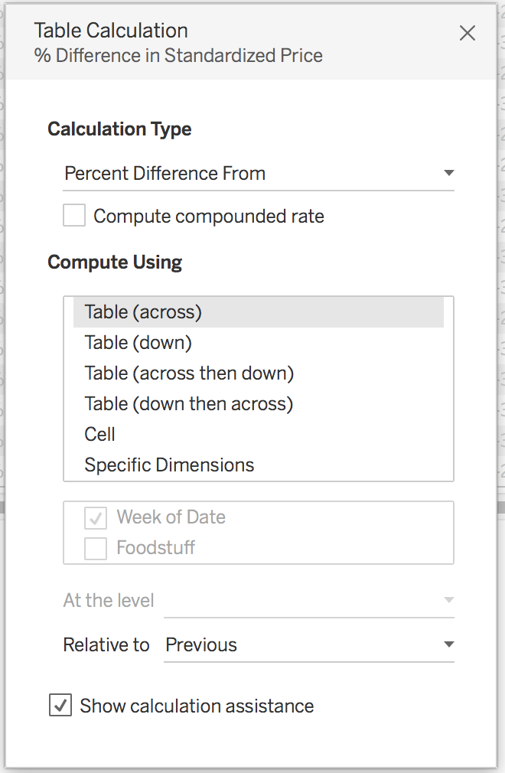

Figure 19. Table Calculation Editor settings

1. Close the **Table Calculation Editor** by clicking on the X on the upper right.

*What we now have is a table showing the percentage change in price for each Foodstuff for each observation week as a percentage of the previous observation. Let’s make this table into a chart!*

1. Click on the **Show Me** command in the upper right, experiment with different ways of visualizing the data by clicking on the various options. If you happen down a “blind alley,” use the back arrow. End by selecting the multiple lines option (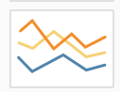).

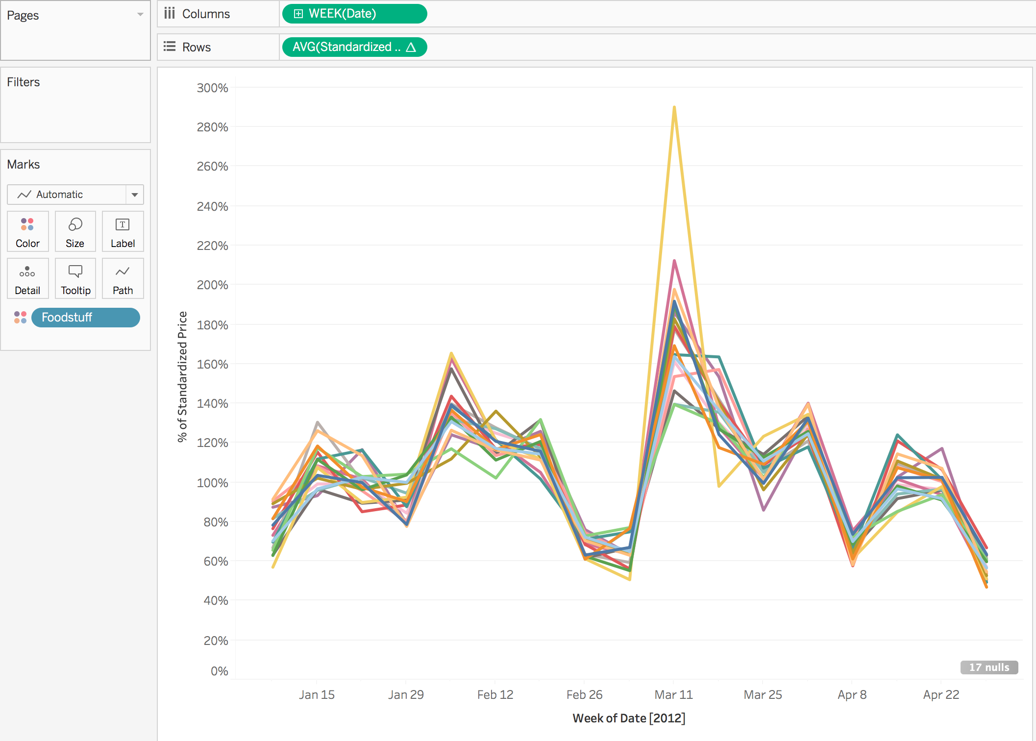

Figure 20. Price Variation by Time (%)

*We see that there is a lot of fluctuation in prices across time. Perhaps these fluctuations might be due to radically different sample sizes? To help examine this question, let’s modify the chart to also show number of observed prices.*

1. *Drag* ***Standardized Prices*** *from* ***Measures*** *to the* ***Size Shelf****.*
2. *Right click on the* ***Standardized Price*** *pill and change the* ***Measure*** *to* ***Count.*** *This will make the width of the lines reflect the number of prices observed for each week.*
3. *Hover over the points along the lines to read the tooltip for each point.* On the legends for Foodstuff (on the right), click on a Foodstuff to highlight the line.

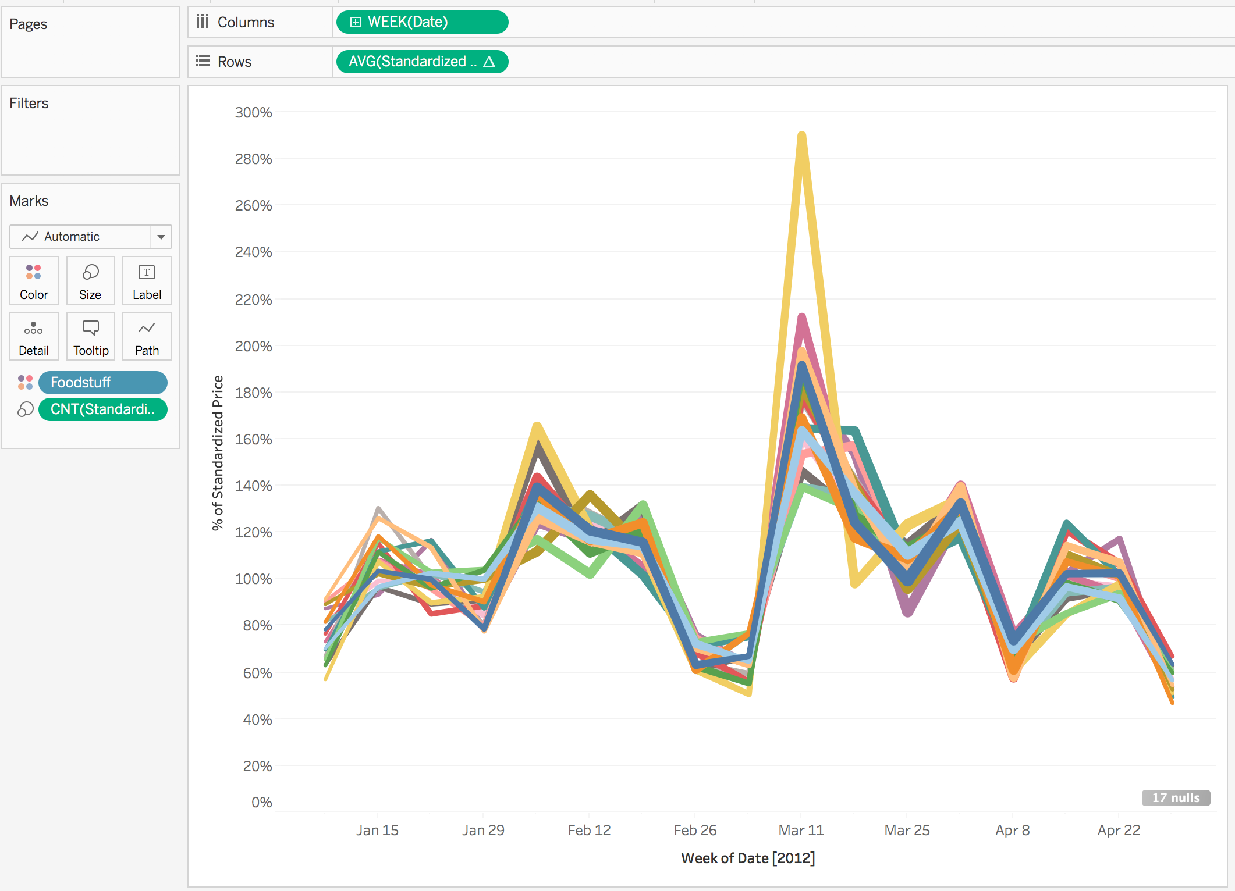

Figure 21. Final line chart - price variation by time, lines thickness sized to show observation count

*The primary purpose of these exercises is to learn how to create various chart types in Tableau. A secondary goal of these exercises is to learn visualization best practices. What do you think about this particular chart? Are there perhaps too many lines? The answer depends on what you are trying to communicate to the user!*

STRETCH TIME / BONUS WORK:

1. We sized the lines to reflect the count of observed prices. Why do you think we could not have sized the lines by the **Number of Records** measure instead? Hint, take a look at the underlying dataset by clicking on the 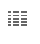 icon in the upper right by **Dimensions**.
2. Does it appear to you that price fluctuations might be due to big differences in observation counts? Probably not.
3. There is a little pill on the bottom right of the chart saying “17 nulls.” Why do you think this is there? How can we make it go away?
4. Suppose that we were showing prices across decades rather than weeks. If that were the case, what might we want to do to help make better comparisons?
5. Go to **Tableau Online Help** by selecting **Open Help** from the **Help** option on the Toolbar. Click on **Design Views and Analyze Data** on the left. Click **Advanced Analytics**. Explore the different pages under **Transform Values with Table Calculations**.

# Module 5: Create an interactive dashboard combining charts

Drill 11: LET’s BUILD A DASHBOARD!

1. Click on the **New Dashboard** icon on the bottom right of the screen (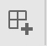).
2. Drag the sheet **Countries** from the left onto the main canvas.
3. Drag the sheet **Price Variation (%) by Time** below the map.
4. Drag the sheet **Price Variation by Country** to the right of the map.
5. On the **Toolbar**, choose **Dashboard** and then **Show Title**. Name the dashboard “Observed Price Variations – World Bank Study 2012.”

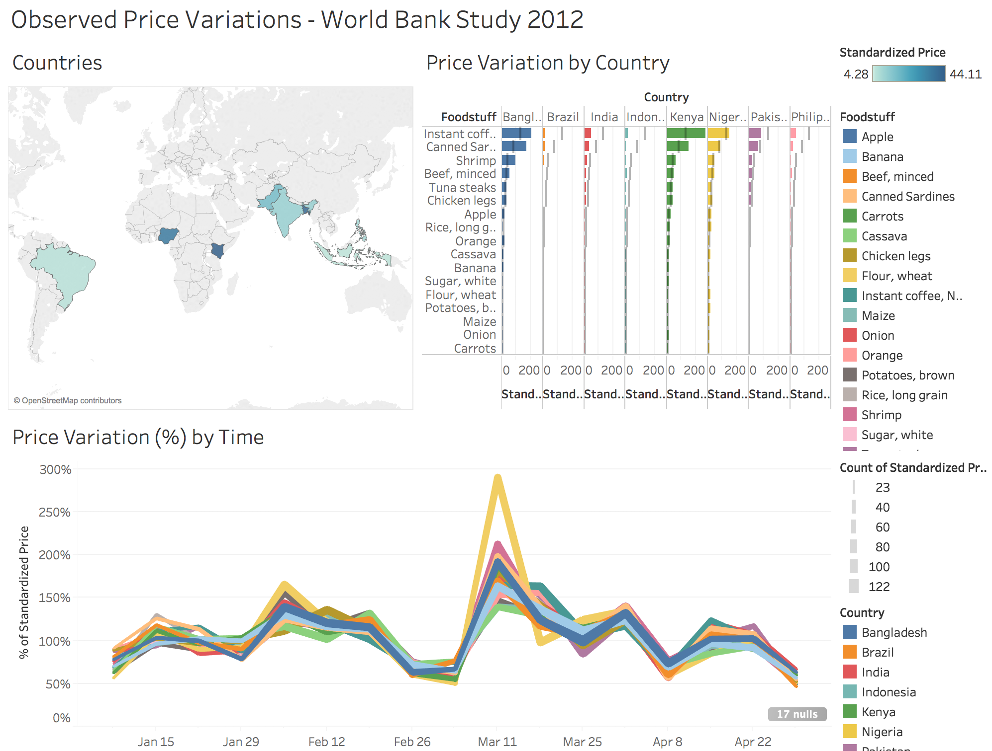

Figure 22. Initial dashboard

Drill 12: IMPROVE THE DASHBOARD

*Up to this point, we have built our charts as individual pieces. In this dashboard, for the first time, we are putting the pieces together. What made perfect sense to do in building a single chart does not always mean the individual pieces will harmonize and make sense together. Data analysis is a journey of iteration.*

*First, examining the legends Tableau has brought into the dashboard, we see by the legend for the map that the map is colored by* ***Nominal Prices****. However, as you hopefully remember, the bar chart and line chart are based off of* ***Standardized Prices*** *to account for different quantity sizes. If we show a measure in different ways on a single dashboard, we want to communicate that clearly to avoid confusion. However, in this case, it makes more sense just to change the map to be colored by* ***Standardized Prices****.*

1. Go to the **Countries** sheet by clicking on its tab. Take **Standardized Price** from **Measures** and drop the pill directly over the **Nominal Price** pill on the **Marks Shelf**. Note, the legend now reads AVG(Standardized Price).

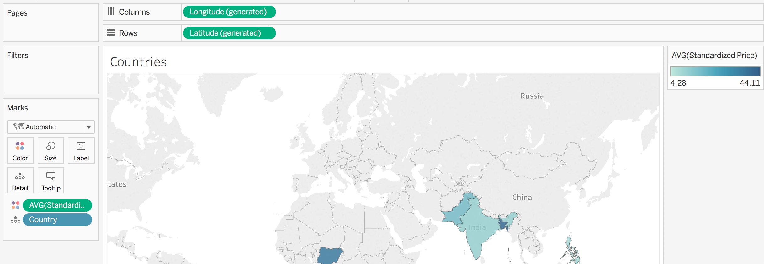

Figure 23. Map colors now using AVG(Standardized Prices) instead of Nominal Price

*We also colored both the bar and the line charts. This could easily lead to users mistakenly correlating colors together for Foodstuffs and for Countries. If we believe colors are needed for both the line and bar charts, this problem can be addressed by better situating legends next to their respective charts. However, in this case, giving colors to each country was originally done mainly to make the chart prettier (though, it can be argued it also helps user decoding). As a rule, when it comes to balancing ease of decoding with making things pretty, always choose to make things easier to decode. On balance, it makes sense to take the color off of the bar chart for the sake of the overall dashboard. Further, for the bar chart, we are trying to fit a lot in on the X axis. To make the axis a little clearer, let’s remove the axis title “****Standardized Price****.”*

1. Go to the **Price Variation by Country** sheet. Right click on the **Country** pill on the **Marks Shelf** and select remove. *Feeling adventurous?* Undo this change and, instead, remove the **Country** pill by just dragging it off the **Marks Shelf** to outside the bottom of the **Marks Shelf**.
2. Double click on the X axis title and remove “**Standardized Price**” from Title to make the Title blank.

*Finally, we sized the lines in the line chart by the* ***Count of Standardized Prices****. Let’s leave this sizing, but remove the legend to have a cleaner dashboard that is easier to read. To make the dashboard even clearer, let’s remove the legend for the map for our next dashboard iteration. Finally, note the indicator “****17 nulls****” on the bottom right of the line chart. Let’s also remove that.*

1. Go to our dashboard sheet, note how the map and bar chart have been changed.
2. Click on the size legend for the bar chart (**Count of Standardized Prices**), choose not to display it by clicking on the X in the upper right.
3. Click on the color legend for the map, choose not to display it by clicking on the X in the upper right.
4. Right click on the **17 nulls** indicator in the bottom right of the line chart. Choose **Hide Indicator**.

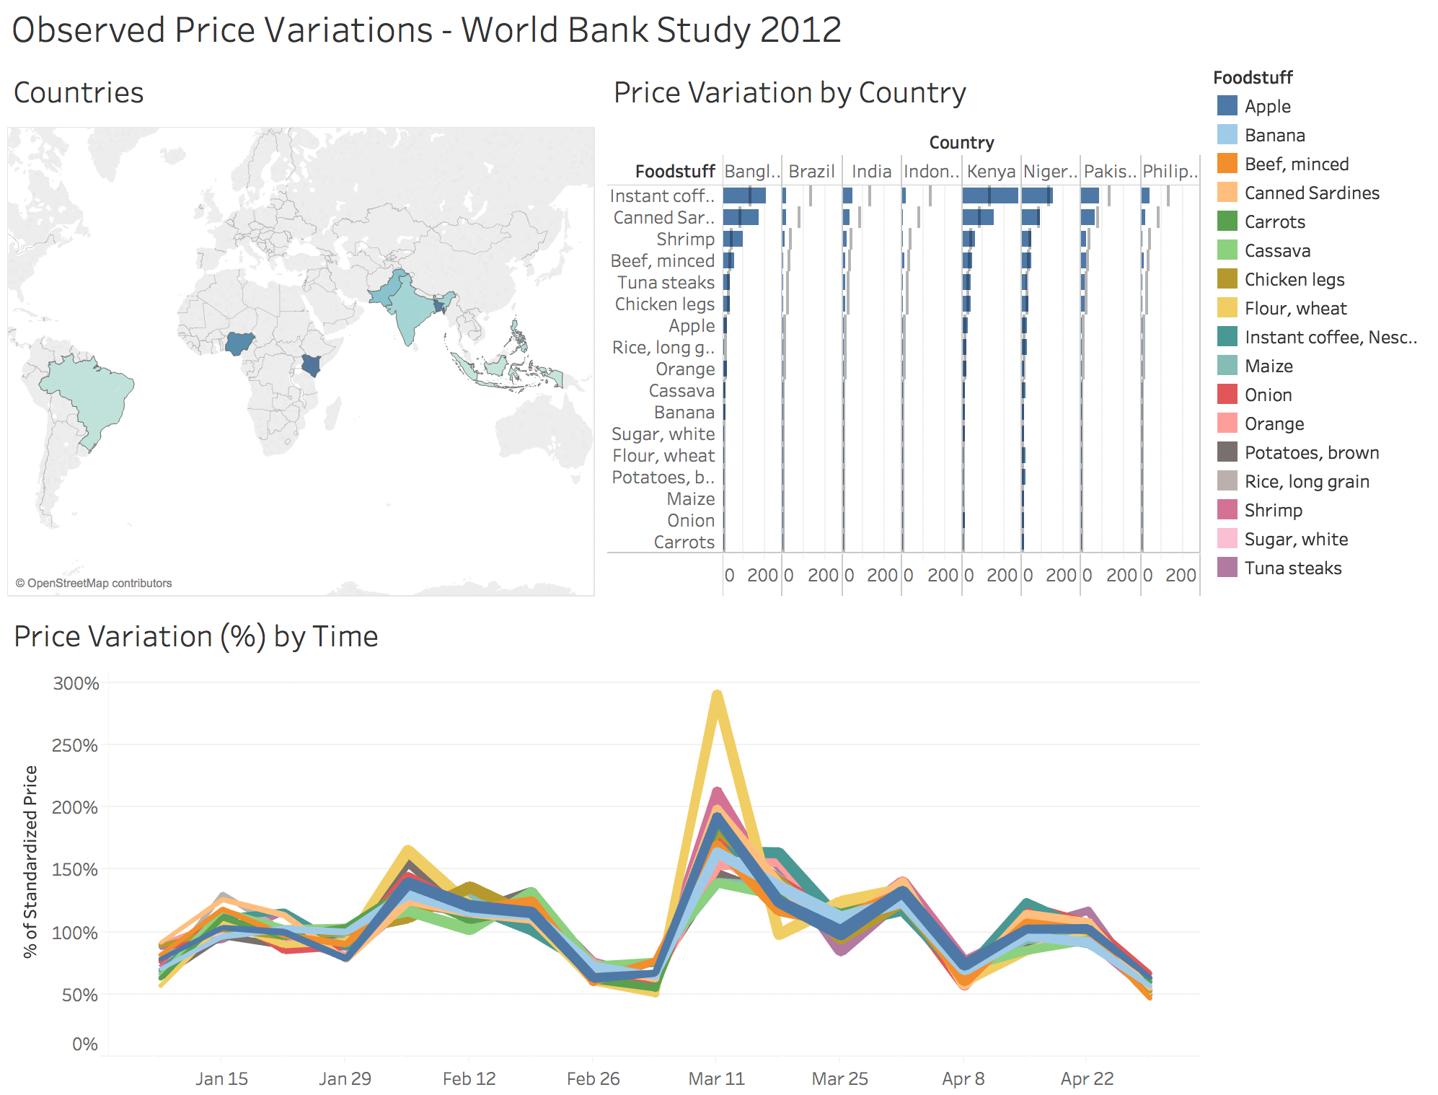

Figure 24. Improved dashboard

*Now we have an “improved dashboard.” While much better than the first iteration (Figure 23), it does have some faults. First, note how country names are being truncated in the bar chart. Second, as a general rule of thumb, using colors to differentiate items loses effectiveness when more than 8 distinctions are being shown. The line chart actually shows 17 different Foodstuffs. As a static image, this chart is trying to differentiate too many Foodstuffs.*

Drill 13: MAKE THE DASHBOARD INTERACTIVE

Try clicking on elements in the charts in the dashboard to see what happens. Let’s take each of the charts in the dashboard and make them interactive to allow for better data analysis/investigation.

1. From the dashboard sheet (Figure 24), click on the map chart.

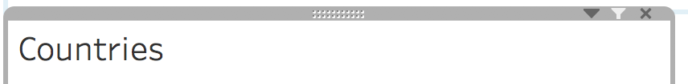

Figure 25. Location of Filter icon

1. Then click on the filter icon on the top right of the chart selection box to tell Tableau we want this chart on the dashboard to filter the other charts on the dashboards.
2. Repeat the last steps for the bar chart and the line chart.
3. Finally, click on the color legend on the right for Foodstuff. Click on the triangle (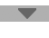) at the top and choose “**Highlight Selected Items.**”
4. *Let’s make sure the user knows the dashboard is interactive*. Double click on the dashboard title and add the text “click on dashboard elements to change the view” as a new italicized line.

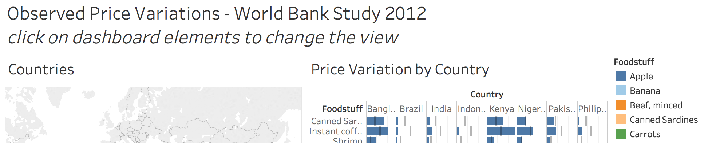

Figure 26. Final title for dashboard letting user know that dashboard is interactive

1. *Pump your hand in the air, you’ve built an interactive dashboard!* Examine how the various dashboard charts and elements now interact with each other.
   1. Click on a country on the map and note how the bar and line chart change. Click on the selected country again to show data for all countries. Select another country again and this time hit your ESC key to remove all selections.
   2. Click on Brazil in the bar chart and note how the map and line chart change. Click on Brazil again to show data for all countries.
   3. Click on Banana on the color legend and note that it highlights Banana in the bar chart and the line chart. Click on Banana again (or hit ESC) to remove highlighting.
   4. Click on one of the lines on the line chart and note how this affects the map and bar chart. Hit ESC to remove selection.
   5. Finally, select multiple elements from multiple charts to see how that affects the data being shown. Hit ESC to remove selections and reset the dashboard.

By putting all of the pieces together, we’ve allowed for a lot more analysis to be done with the data. An initial observation from this exercise, that was not apparent until now, is that we do not have data from all of the countries for all of the observation dates. For example, click on Brazil on the map and note the gaps in the line chart showing that there were weeks for which no data was collected from Brazil.

Bravo! Job well done!

STRETCH TIME / OPTIONAL HOMEWORK:

1. Your boss comes to you and congratulates you for doing an awesome job and outshining your peers! However, she is a little concerned that the dashboard does not give a full picture of the data. She asks you to create a new visualization that highlights the fact that, between countries, there were weeks where data was collected for some countries and not others. For extra credit, create a chart or dashboard investigating this. Remember, data analysis is an iterative journey, not a final destination!
2. Go to Tableau Online Help and research how to make Story Points.
3. Put the dashboard we built as well as your new chart/dashboard into a Story.
4. Save this as a TWBX file and send it to [paul@vizalyst.com](mailto:paul@vizalyst.com) if you want comments on this work.
5. Itching to do even more. Create a Tableau Public account and save your work to Tableau Public. Now, anyone with a web browser can view and interact with your work. Instead of sending a TWBX, just send the URL for your viz!